Chapter 9

# Try It Yourself: Exploring R-Squared in Multiple Linear Regression

## StatCrunch Instructions

Fit Regression Model:

1. Open the penguins.csv data in StatCrunch.
2. Stat → Regression → Multiple Linear
3. Y variable → bill_depth_mm
4. X variables → (*the explanatory variable(s) in your model)*
   1. If your model includes categorical variables then you will need to create indicator variables of them **first** (Data → Indicator → Select your categorical variable); then include all but one of them in your model. For example, if a categorical variable has three levels/values then you will only include two of the corresponding indicator variables in your model.
   2. If your model includes sex, then include the “*sex = male”* variable
   3. If your model includes species, then include both the “*species = Adelie”* and the “*species = Chinstrap”* variables
5. Click Compute!
6. Record R-squared value in a new column, titled “R_squared”, along with the number of variables in a column titled “number_of_variables” (e.g., sex, body_mass_g, etc.) in your model
7. Take note of the slope coefficient for the model based on body_mass_g only.
8. Repeat steps 2-6 for each model

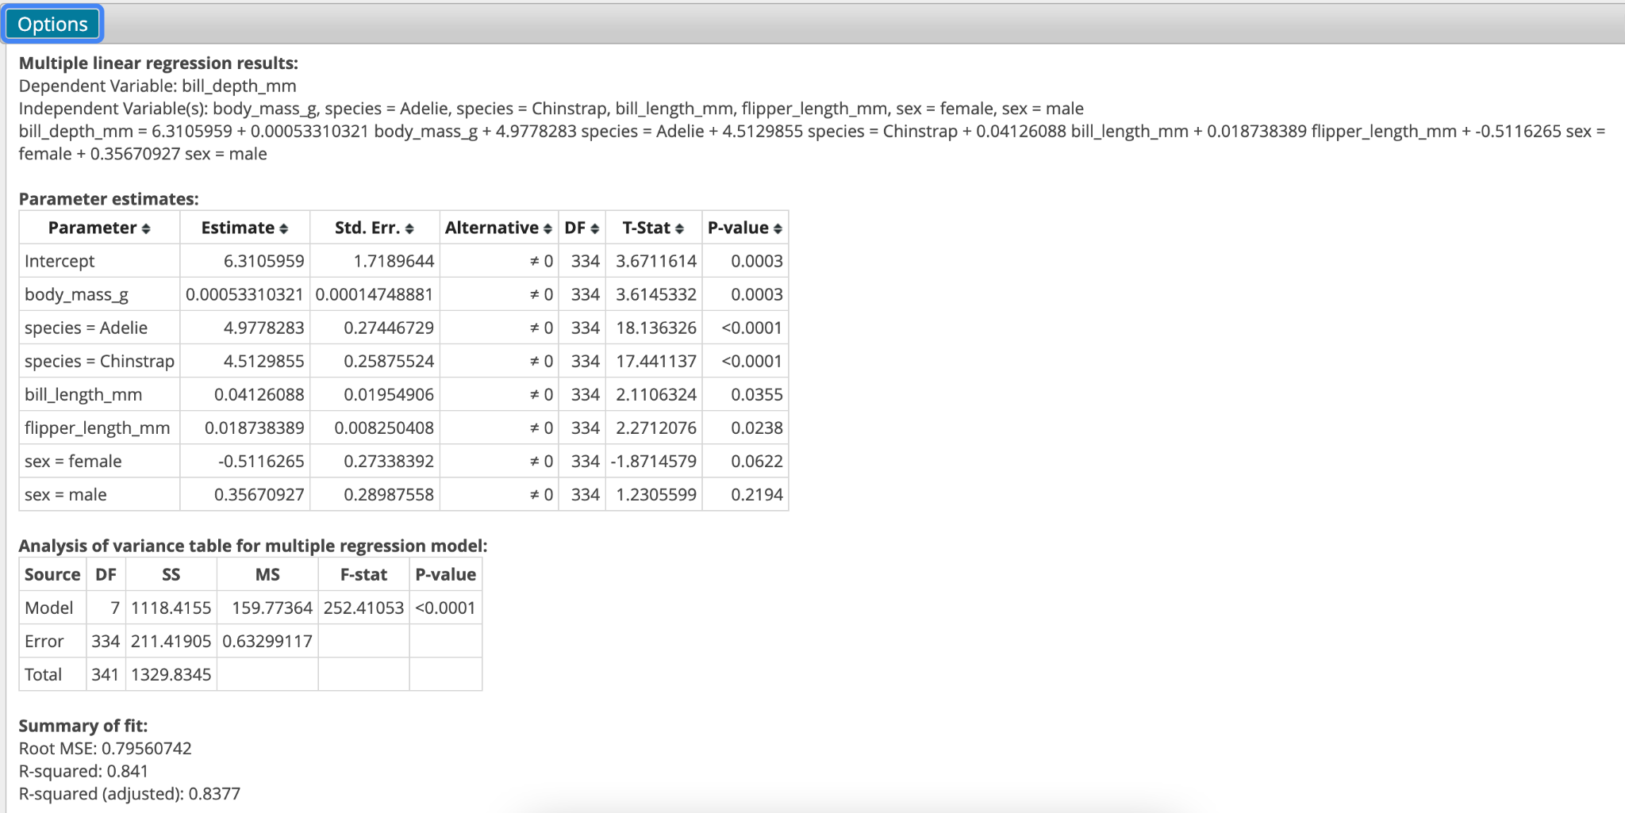

Create the scatterplot for the R-squared versus number of explanatory variables:

Graph->Scatter Plot

X variable -> number_of_variables

Y variable -> R_squared

Click Compute!